https://app.quicktype.io/

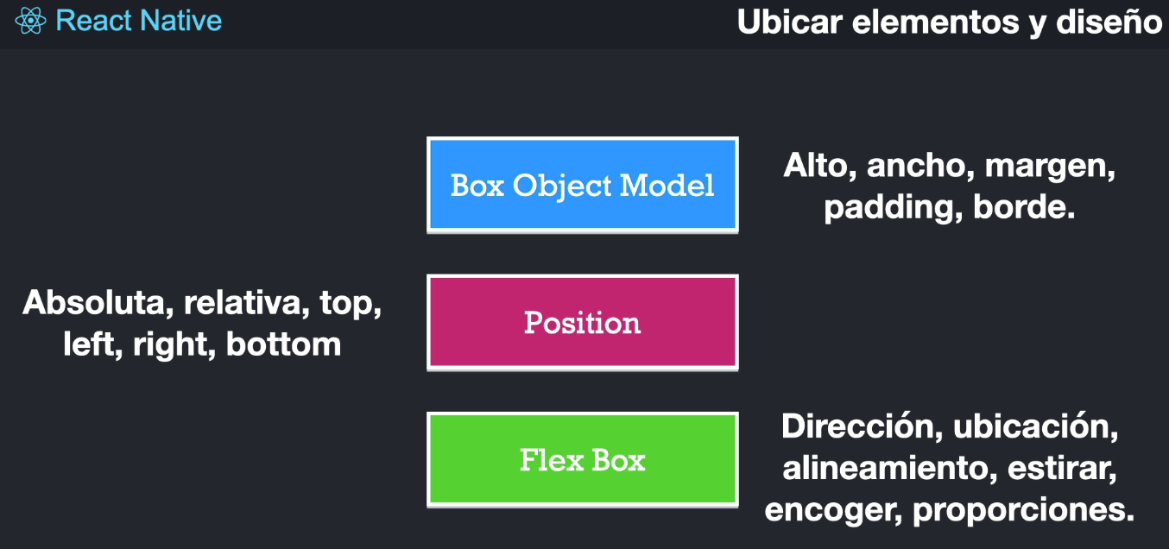

https://reqres.in/

https://reactnative.dev/docs/environment-setup

https://gist.github.com/Klerith/89d5288dec7ff254913453d26a63e981

<https://ethercreative.github.io/react-native-shadow-generator/>

<https://reactnative.dev/docs/button>

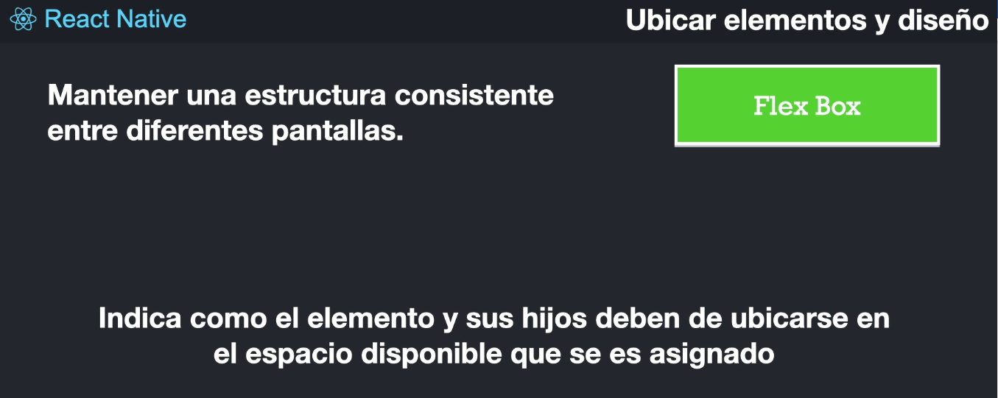https://reactnative.dev/docs/flexbox

